A SASANK REDDY

Virtual key for your repositories

**Phase 1 - Virtual Key for Your Repositories**

This document contains sections for:

* Sprint planning and Task completion
* Core concepts used in project
* Flow of the Application.
* Demonstrating the product capabilities, appearance, and user interactions.
* Conclusions

## **Sprints planning and Task completion:**

**Agile Process:**

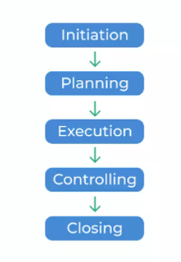

The project is planned to be completed in 3 sprints. Tasks assumed to be completed are

* Project Analyzing for the flow and for the implementation.
* Creating the flow of the application.
* Initializing git repository to track changes as development progresses.
* Writing the Java program to fulfill the requirements of the project.
* Testing the Java program with different kinds of User input
* Pushing code to GitHub.
* Creating this specification document highlighting application capabilities, appearance, and user interactions.

**Flow of the Application****:**

## **Flow Chart:**

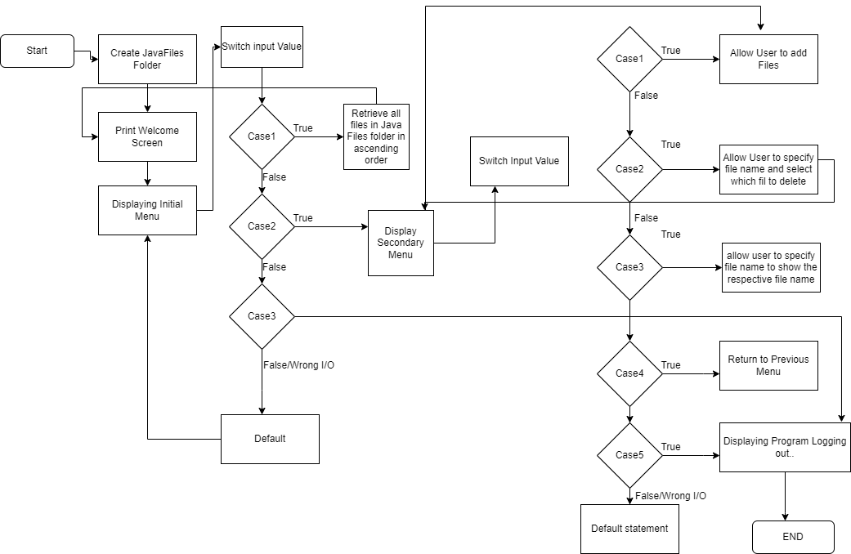

## **Demonstrating the product capabilities, appearance, and user interactions**

**Technologies used in the Project:**

Java , Eclipse, GitHub, gitbash

**Java concepts:**

Methods,

Data Structures

Sorting and Searching techniques

Array list.

**GitHub Repository**

**Link:** [**https://github.com/sunnyairala/Virtual-Key-for-Your-Repositories.git**](https://github.com/sunnyairala/Virtual-Key-for-Your-Repositories.git)

**Appearance and user Interactions**

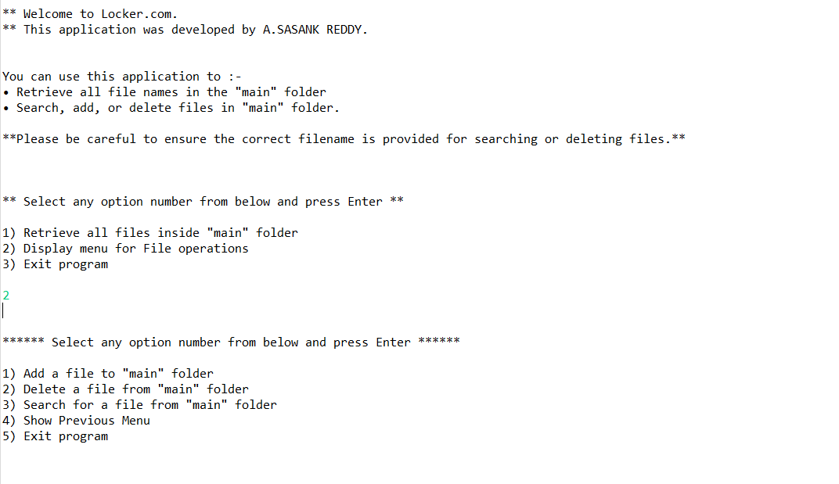

## 

## **Conclusions:**

Further enhancements to the application can be made which may include:

* Conditions to check if user is allowed to delete the file or add the file at the specific locations.
* Asking user to verify if they really want to delete the selected directory if it’s not empty.
* Retrieving files/folders by different criteria like Last Modified, Type, etc.
* Allowing user to append data to the file.